

**Discipleship and Nurture Ministry**

***“To establish, deepen and strengthen your roots in Christ”***



Ministry Aims

The Discipleship and Nurture (D&N) Ministry provides focus and attention to:

* Scriptural training and instruction
* Emphasis on individual church members
* Spiritual development and growth

Every believer matters to Christ and a disciple of Christ is a learner. Discipleship is a relationship where we stand in Christ and take on His character. We learn from Him, how to live life as He would.

It is the intention of our Church to help each believer to grow spiritually as a child of God. Intentional courses at different levels are being planned and conducted to build our foundation in the word of God and spiritual discipline. We are not just looking at being informed, but to be transformed as we discipline ourselves to become true Disciples of Christ.

The courses listed in the AMKMC Discipleship Blueprint are arranged from basic to advanced levels to take a believer on a journey to spiritual maturity. They will be conducted at different times of the year, under the direction of the Pastors, with the assistance of the Pastoral Team Members and volunteers in the various lay ministries in AMKMC. Whether you are a new believer, or seeking to strengthen your biblical foundation, our Church wants to nurture you to spiritual maturity.

AMKMC Discipleship Blueprint

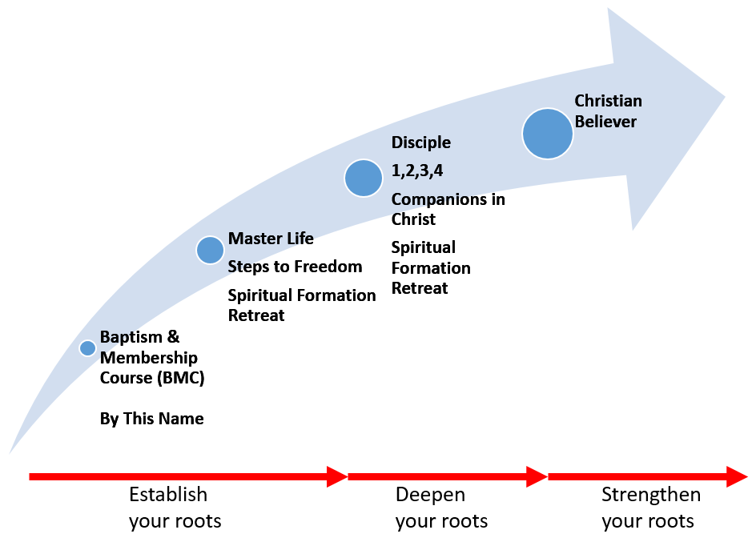

|  |  |  |
| --- | --- | --- |
| **ESTABLISH your roots**   * Baptism and Membership Course * Master Life * By This Name | **DEEPEN your roots**   * Disciple 1 * Disciple 2 * Disciple 3 * Disciple 4 | **STRENGTHEN your roots**   * Christian Believer   *Future course offerings are under evaluation |
| * Steps to Freedom * Spiritual Formation Retreat | * Companions in Christ * Spiritual Formation Retreat | *Future course offerings are under evaluation |

Course Information

There will be a compulsory D&N Orientation Day for those wishing to find out more information about the courses offered. Detailed class schedules and course materials will also be distributed. Please refer to the bulletin when the information becomes readily available.

|  |  |  |  |  |
| --- | --- | --- | --- | --- |
| **Course** | **Duration** | **Course Materials** | **Cost of Materials** | **Remarks** |
| Disciple 1 | 34 weeks | 1 Course workbook | $30/copy | Please note that there will be a compulsory D&N Orientation Day where specific information like class schedule will be given out. |
| Disciple 2, 3 and 4 | 32 weeks | 1 Course workbook | $30/copy |
| Christian Believer | 30 weeks | 1 Course workbook and 1 Book of Readings | $65/set |
| Master Life | 24 weeks | 4 Member Books | $37/set |
| Companions in Christ | 28 weeks | 1 Course workbook | $20/copy |
| By This Name | 15 weeks | 1 Course workbook | $25/copy |
| Steps to Freedom | 1 day | 1 Workbook | $5/copy | Please note that registration opens 6 to 8 weeks before actual date of retreat, and closes 2 weeks before the date of retreat. |
| Spiritual Formation Retreat | 2 days, 1 night | Materials provided | TBC |
| Baptism and Membership Course | 10 weekly sessions and 2 full-day retreats | 1 Course folder  1 Church Membership Manual | $5/set | Group discussions  Retreat 1: Steps to Freedom  Retreat 2: Methodism and Spiritual Gifts |

* + - * **Cost of manuals/workbook correct at time of print**

**Registration Procedure**

* Please note that there is no orientation for the Steps to Freedom and Spiritual Formation retreats. Information will be provided closer to the date of the retreat, and registrants will be invited accordingly.
* Fill up the **D&N Registration Form** and select your desired course.
* Attend the **compulsory D&N Orientation** which will provide detailed Course Information, Class Schedule and Class Materials.

**BAPTISM AND MEMBERSHIP COURSE**



The Baptism and Membership Course (BMC) is a preparatory course for anyone who is preparing to be baptized or become a member of Ang Mo Kio Methodist Church. The course involves 10 weekly meetings plus 2 full-day retreats. BMC fulfils the following purposes:

1. To ensure candidates are fully instructed in the basic foundation of the Christian faith.
2. To communicate the church’s vision and beliefs.

BMC Prerequisites and Course Outline:

* Minimum of 6 months regular attendance at Sunday services prior to registration.
* 10 weekly sessions, inclusive of a small group discussion.
* 2 full-day retreats, inclusive of:
  + Steps to Freedom
  + Teaching on the Holy Spirit and Methodism

The course culminates with a Baptism Service for those getting baptized, and a Confirmation and Reception into Membership Service for all participants to officially welcome them into the AMKMC family. More information will be available closer to the opening date of registration.



***A Bible study series aimed at transformation – not just information***

**DISCIPLE** is a program of disciplined Bible Study aimed at developing strong Christians. This study, using the Bible as the main text, is conducted through small groups for fellowship, study, prayer and preparation for servant hood. The purpose of DISCIPLE is expressed in the words of Ephesians 4:12, “to equip the saints for the work of the ministry, for building up the body of Christ.” There are 4 books in the DISCIPLE program. Those who are seeking to grow deeper in the word and spiritually will benefit from attending this program.

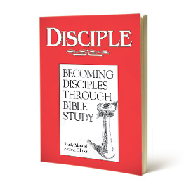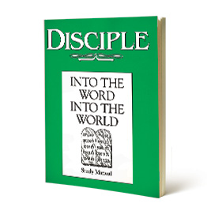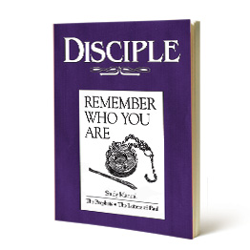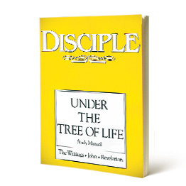



**DISCIPLE 1: BECOMING DISCIPLES THROUGH BIBLE STUDY** is the foundation of the DISCIPLE Bible Study program, using biblical language, images, and scholarly work to understand the Bible over 34 weeks.

This study requires reading large portions of Scripture each week and is based on careful study and preparation. During the course, groups will move through the biblical stories of Creation to the New Jerusalem. The titles of the sessions along with theme words; theme verses; and major persons, events, and topics will set the sequence of the biblical story in the minds of the participants. The principal Scripture for each session follows the chronological movement of the biblical story.



**DISCIPLE 2: INTO THE WORD, INTO THE WORLD** understands the growing Christian as under discipline in community and in ministry to the world, approaching all experiences of life as opportunities for faithful witness and service, run over 32 weeks.

This study concentrates on four books: Genesis, Exodus, Luke, and Acts (eight lessons on each book). Appropriate connections are made to other parts of Scripture both through reading and study assignments and through commentary in the study manual. Participants will read familiar passages, see them in fresh ways, and anticipate that God will speak through them.



**DISCIPLE 3: REMEMBER WHO YOU ARE** will read the major and minor Old Testament prophets, and will read the thirteen letters traditionally attributed to Paul over 32 weeks.

Several themes weave their way through the study: the call to remember, the call to repentance, the need for renewed vision (eyes to see, ears to hear), and the place of community. The prophets and Paul are continually calling hearers and readers back to their God and to a sense of who they are as a people “set apart.” The prophets and the community cannot be separated. The prophets spoke for God, out of the community, and to the community. Paul’s experience of the risen Lord, his relationship to the community he addressed, his Jewish traditions, and the Greco-Roman culture of his day merged in his writing of the letters. Paul used the language of his culture to carry the message that arose out of his roots in the Hebrew Scriptures and Judaism.



**DISCIPLE 4: UNDER THE TREE OF LIFE** is a 32-week study concentrating on the writings in the Old Testament – Ruth, 1 and 2 Chronicles, Ezra, Nehemiah, Esther, Job, Psalms, Proverbs, Ecclesiastes, Song of Solomon, Lamentations, and Daniel. New Testament Scriptures include the Gospel of John; 1, 2, and 3 John; James; Jude; and Revelation.

Emphasis on the Psalms as Israel’s hymnbook and prayer book leads naturally to an emphasis on worship in the study. Present though the entire study is the sense of living toward completion, toward the climax of the message and the promise, extravagantly pictured in the Book of Revelation.

**BY THIS NAME**, a 15-week study, explains the Bible’s core message to people *who have no prior knowledge about the Bible*. Using the architecture of the gospel of John, the book clearly sets apart the God of the Bible from all other gods. It establishes the authority of Scripture and gently compares the biblical worldview to eastern worldviews. It ties together key Old and New Testament stories to reveal the identity of God and the nature of sin, with the aim of answering two questions: Who is Jesus and what is the story of the cross and the tomb all about?

**CHRISTIAN BELIEVER** is a 30-week study for growing and mature believers who wish to deepen their understanding of how Christ’s teachings shape our practice of faith and the way we view our world. It focuses on the classical teachings of the Christian faith as enshrined in the ecumenical creeds, presenting, explaining and interpreting them in a way that participants can understand through the use of words, symbols and hymns.



“Knowing God With Heart & Mind” is the central theme of this course. It summarizes the message that, if the study of doctrine is to result in wholeness of life, the issues of the heart and the issues of the mind must come together. Doctrine moves from the head to the heart.

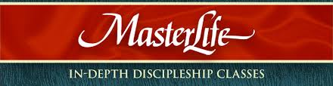

***Master Life:*** *Developing a Rich Personal Relationship with the Master*

An excellent 24-week equipping program to help persons move toward maturity in Christ, Master Life is appropriate for both new Christians and experienced believers. A blend of biblical study assignments and real-life application, it takes truth from the head to the heart.

The course is structured according to 4 Member Books, each taking 6 sessions to cover.

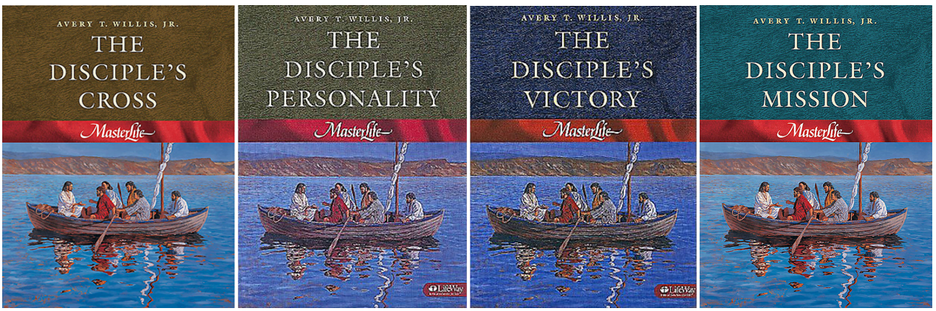

In addition to gaining victory over areas of weakness, participants will be encouraged to master living in the Word, Prayer, Personal Purity, Witnessing, and other key Disciplines of Faith. Every disciple is to heed the call to follow after the Master throughout his/her life so as to be so transformed that by His grace we can begin to be involved in His mission in our home, church and the world.



**COMPANIONS IN CHRIST (CIC)** is a Spiritual Formation program which provides participants diverse, imaginative settings for learning the spiritual disciplines of prayer, scripture study, worship, ministry and Christian conversation.

This series is conducted in a small group of 8 - 12 members and will culminate in a day retreat. There will be daily devotional readings for 5 days each week and the group meet weekly over 28 weeks. CIC will offer you the opportunity to focus on your relationship with Christ and grow in your openness to God’s presence and guidance.

There will also be times where you and members of your group will participate in community sharing, as you explore common stories, questions, and discoveries about your relationship with Christ. The unique aspect of this experience is that members or your small group, who are indeed your companions on the journey, will encourage your searching and learning.

The most refreshing discovery that you can make personally at the end of the journey, will be when you realize that Jesus is your companion and has been with you all, all the time! To God be the Glory indeed!

The course is structured according to the CIC workbook, covering 5 modules over 28 sessions.

**STEPS TO FREEDOM (STF)** is a Christian tool which includes a spiritual inventory to help us identify and break free from condemning thoughts, compulsive behaviours, personal conflicts, spiritual struggle & despair and any type of spiritual bondage

The purpose of this workshop is to

- To help you resolve personal & spiritual conflicts

- To break free from bondage

- To renew your mind

- To experience daily victory as a child of God

****The facilitators will walk through with you step by step the 7 Steps:

* + Counterfeit vs Real
  + Deception vs Truth
  + Bitterness vs Forgiveness
  + Rebellion vs Submission
  + Pride vs Humility
  + Bondage vs Freedom
  + Curses vs Blessings

This workshop is quite intense, focused and intentional. The STF tool is beneficial for anyone who desires to be set free; or for those who struggle with temptations, bondages and perennial problems.

**SPIRITUAL FORMATION RETREATS**



The early Wesleyans were so regular in practising spiritual disciplines that they were called “Methodists”. The spiritual disciplines are simply the practices that Christians, through the centuries have found useful in the pursuit of spiritual formation, which is pursuit of Christ-likeness.

In practising some of the spiritual disciplines, we open our hearts to the presence of God in our lives and allow the grace of God, empowered by the Holy Spirit, to probe and guide us not only to a deeper relationship with Him but to fruitful Christian living bearing the character traits of Christ.



The retreats will be on a 1-day basis, details announced accordingly in bulletin when available. During these Spiritual Formation Retreats, we will guide participants through some of disciplines as follows: **Experiential Prayer and Practising the Presence of God**

****Rediscovering the sacredness of each moment by

* + Exploring and experiencing various prayer forms.
  + Observing Sabbath moments in the rhythm of the day.
  + Reflecting and allowing God to speak while reflecting on your relationship with God.

**Discipline of Examen**

* + 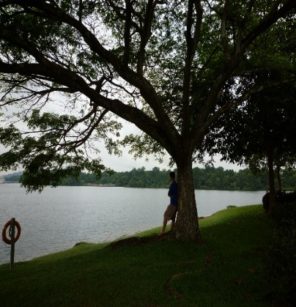The Discipline of Examen is a way of prayer that **examines or assesses one’s life before God on a regular basis**.
  + Come and join us to learn this ancient practice of prayer so that we will not live wasted lives and more importantly, it will help us be increasingly in tune with the Spirit of God in our lives.

**Contemplative Prayer**

* + ****A journey of faith incorporates a life of prayer in **Contemplative Prayer**.
  + We seek to enrich our spiritual life and experience how we can grow deeper in our relationship with God.

**APOLOGETICS FORUMS** are for you to learn about the difficult questions that challenge Christianity, providing opportunities for you to ask questions, to strengthen your faith so you will know *what* you believe and *why* you believe what you believe.



They are usually held on Sunday afternoons. Watch out for announcements in our weekly bulletin for details.

**MID-WEEK BIBLE STUDIES** are planned normally for the 2nd half of the year, where invited speakers and teachers of the Bible share and bring alive the word of God to us. They are usually held on a weekday evening. Watch out for announcements in our weekly bulletin for details.

Periodically, other courses may be introduced when the Pastoral Office seems suitable for a believer’s growth. The aim is to always stay fresh and be recharged in our spiritual life by the living Word of God. Do look out for such announcements in the weekly bulletin!

***Discipleship is a Way of Life***

**“Discipleship isn’t a program or an event; it is a way of life.** It is not for a limited period, but for a whole life. Discipleship isn’t just for beginners alone; it is for all believers for every day of their life. Discipleship isn’t just one of the things the church does, it is what the church does. It’s not just part of the advancement of God’s Kingdom; the existence of serious disciple is the most important evidence of God’s work on earth.

Without enough of these workers, the task languishes and the work remains incomplete (see Mathew 9:35-38)” – Bill Hull

***Discipleship Requires Commitment***

**Discipleship requires us to take up our cross daily and follow Jesus (Luke 9:23).** It requires commitment on our part, and as we keep our commitments and give ourselves to the process, we will experience a depth of relationship with Christ that will spur us on for the rest of our life. Without discipleship, we lose our vibrancy in Christ.

***Discipleship Is a Decision***

Courses and programs organized are announced periodically in the bulletin. Take the step of faith and register to attend when applications begin. Commit to grow. Pursue God with a passion. You will be fulfilled.

***Be blessed. Decide today to be a disciple for Christ.***

*“Christianity without discipleship is always Christianity without Christ.”*

Dietrich Bonhoeffer

©Discipleship & Nurture Ministry, Ang Mo Kio Methodist Church